Name: Date: Period:

**Rule of Law & Types of Law**

Use the word bank to fill in the blanks:

Rule of law means that the country is guided by laws and not individuals. It also means that even government officials must who make and enforce legislation must obey the law. In 1754 B.C., in ancient Babylon, a king created a collection of laws known as the

Code of Hammurabi_. Another influence on systems of law came from ancient Rome in 450 B.C. which were laid out in public for both Plebeians who were the wealthy and the common Plebeians known as

Patricians . Most laws passed during the middle-ages were those created by Kings & the Church, but during the Enlightenment legislatures such as Parliament began passing laws which we call

statutes. Another type of law was created by judges

known as Common law which based current court rulings

based on past decisions. Civil laws provide rules for lawsuits in which individuals sue other individuals for damages. Criminal laws

create rules and punishments laws that help maintain a safe and

orderly society. Constitutional law deals with rights created by

constitutions. Military law deals with people who serve in the armed forces for dealing with security and discipline. These laws are

created at these three levels of government: Federal ,

State, and local.

Word Bank:

|  |  |  |  |
| --- | --- | --- | --- |
| **Civil** | **Code of Hammurabi** | **Common Law** | **Constitutional** |
| **Federal** | **Local** | **Rule of Law** | **State** |
| **Statutes** | **Twelve Tables** | **Military Law** | **Patricians** |
| **Criminal law** |  |  |  |

□ □ □ □ □ □ □ □ □ □ □ □ □ □ □ □ □ □ □ □ □ □ □ □ □ □ □ □ □ □ □ □ □ □ □ □ □ □ □ □ □ □ □ □ □ □ □ □ □ □ □ □ □ □ □ □ D □ D □

□ □

□ □

□ □

□ □

□ Fill in the Types of Laws for each example: □

□ □

□ □

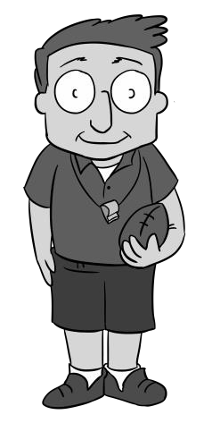□ □

I was arrested for drinking and driving. My case involves this type of law?

□ □

□ □

□ □

□ □

□ □

□ □

□ Criminal law □

□ □

□ □

□ □

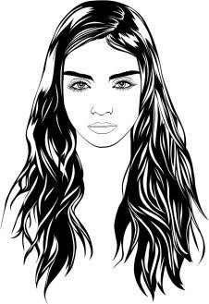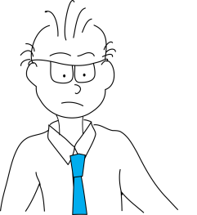

I’m suing the company I worked for, for violating their contract with me.

My case involves this type of law?

**Civil**

I’m suing the government for violating my rights. My case involves this type of law?

**Constitutional**

I was court-martialed for failing to follow orders.

My case involves?

□ □

□ □

□ □

□ □

□ □

□ □

□ □

□ □

□ □

□ □

□ □

□ □

□ □

□ □

□ □

□ □

□

□ □

□ □

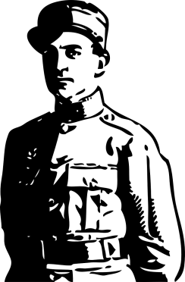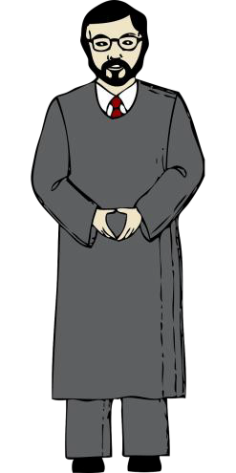

**______ _ _ _ _ _ _ _ _ _ _ _ _ __**

My court uses precedents to determine current cases. This is known as?

**___ _ _ _ _ _ _ _ _ _ _ _ _ _ _ _ __**

□ □

□ □

□ □

□ □

□ □

□ □

□ □

□ □

Military law

□ □

□ □

□

□ □

□ □

□ □

□ □

□ □

□ □

□ □

□ □

□ □

□ □

□ □

□ □

□ □

Common Law

□ □

□ □

□ □

□ □

□ □

□ □

□ □

□ □

□ □

□ □

□ □

□ □

□ □

□ □

□ □

□ □

□ □ □ □ □ □ □ □ □ □ □ □ □ □ □ □ □ □ □ □ □ □ □ □ □ □ □ □ □ □ □ □ □ □ □ □ □ □ □ □ □ □ □ □ □ □ □ □ □ □ □ □ □ □ □ □ D □ D □